**PYTHON PROJECT REPORT**

(Project Semester: January-April 2025)

**Title of the Project: Electric Vehicle Population Data Analysis & Visualization**

**Submitted by:**

**Khushi Kumari  
Registration No.: 12310965  
Programme and Section: B.Tech CSE (K23FD)  
Course Code: INT375**

**Under the Guidance of:  
Baljinder Kaur (UID : 27952)**

**Discipline of CSE/IT**  
**Lovely School of Computer Science & Engineering**  
**Lovely Professional University, Phagwara**

**DECLARATION**

I, **Khushi Kumari**, student of **Bachelors of Technology (B.Tech)** under CSE/IT Discipline at Lovely Professional University, Punjab, hereby declare that all the information furnished in this project report is based on my own intensive work and is genuine.

Date: 11-April-2025  
Registration No.: 12310965  
Name of the Student: **Khushi Kumari**

# ****CERTIFICATE****

This is to certify that **Sakshi Srivastava** bearing Registration No. **12310965** has completed **INT375** project titled **“Electric vehicle population data analysis & visualization”** under my guidance and supervision. To the best of my knowledge, the present work is the result of her original development, effort, and study.

**Baljinder Kaur**  
**Assistant Professor**  
**School of Computer Science & Engineering**

**Lovely Professional University**  
**Phagwara, Punjab**

Date: **11-April-2025**

**ACKNOWLEDGMENT**

I would like to express my sincere gratitude to **Baljinder Kaur Ma’am**, my project guide, for their invaluable support, guidance, and encouragement throughout the development of this project. Their expert insights and constructive feedback have been instrumental in shaping the project's outcome.

I am also thankful to **Lovely Professional University** for providing a conducive learning environment and access to resources that made this project possible. Additionally, I extend my appreciation to my professors and peers for their continuous motivation and insightful discussions, which greatly enhanced my understanding of the subject.

Lastly, I would like to acknowledge the unwavering support of my family and friends, whose encouragement has been a source of inspiration throughout this journey.

# ****TABLE OF CONTENTS****

1. Introduction
2. Source of Dataset
3. Dataset Preprocessing
4. Analysis on Dataset (for each objective)
   * i. General Description
   * ii. Specific Requirements
   * iii. Analysis Results
   * iv. Visualization
5. Conclusion
6. Future Scope
7. References

# ****INTRODUCTION:****

# In the era of sustainable development and climate-conscious decision-making, tracking the adoption of electric vehicles (EVs) is crucial for understanding environmental progress, infrastructure needs, and market trends. One powerful way to uncover meaningful insights from EV population data is through Exploratory Data Analysis (EDA). EDA allows analysts to identify growth patterns, regional adoption differences, and other key trends using visual and statistical tools.

# This project, titled “Electric Vehicle Population Analysis Using Python,” leverages EDA techniques to explore changes in EV adoption over time. The objective is not only to manage and visualize EV population records, but also to extract actionable insights that can support policy-making, business strategies, and public awareness. Python, with its versatile data science libraries such as Pandas, Matplotlib, Seaborn, and Plotly, is well-suited for this task.

# Key Goals of the Project:

# Data Collection & Preprocessing: Importing real-world or simulated EV registration data and preparing it for analysis.

# Trend Analysis: Understanding how the EV population has evolved over the years — nationally and regionally.

# Adoption Patterns: Identifying states, cities, or regions with the highest and lowest growth in EV usage.

# Segment Breakdown: Analyzing the data based on vehicle types (e.g., fully electric, hybrid), manufacturers, and models.

# Visualization: Creating informative charts such as line plots, bar graphs, heatmaps, and geo-maps to show trends and patterns.

# Insight Generation: Providing meaningful summaries that support EV infrastructure planning, environmental assessments, and investment decisions.

# Why This Project Matters:

# Unlike standard reporting systems that focus on static figures, this project digs deeper by exploring how, where, and why the electric vehicle population is changing. It supports a wide range of applications including:

# Government agencies planning EV incentives and charging networks.

# Businesses and startups seeking data-driven insights for EV-related services.

# Environmental researchers tracking the impact of EV growth on emissions.

# Students and data science learners interested in sustainability and real-world analytics.

# Skills and Tools Gained:

# Through this project, users will enhance their skills in:

# Python programming and data manipulation

# Data visualization and storytelling

# Real-world dataset handling

# Drawing conclusions from trends and outliers

# Conclusion:

# The “Electric Vehicle Population Analysis Using Python” project demonstrates how EDA can turn raw transportation data into powerful narratives. By interpreting shifts in EV adoption, we gain a better understanding of the transition to greener mobility. This type of data-driven insight is essential for shaping the future of transportation and sustainability.

# ****2. SOURCE OF DATASET****

The dataset utilized in this project was obtained from the **U.S. Government’s Open Data Platform** – [**catalog.data.gov**](https://catalog.data.gov), which serves as a comprehensive repository of datasets across various sectors including business, economics, health, and environment. The specific dataset used in this project is titled:

**“Electric Vehicle Population data analysis & visualization”**  
**Dataset URL:** <https://catalog.data.gov/dataset/electric-vehicle-population-data>

This dataset provides comprehensive records on the population of electric vehicles (EVs) registered across various U.S. states and counties. It includes key details such as vehicle type, make, model, electric range, model year, and geographic distribution. Maintained by official government entities, this dataset is a reliable source for analyzing trends in electric vehicle adoption and infrastructure planning.

**Rationale for Choosing This Dataset**

This dataset was selected for the project due to its significance in evaluating:

* **Adoption trends** of electric vehicles over time and geography.
* **Popular EV models and manufacturers** dominating the market.
* **Distribution of EVs** by electric range and fuel type (battery electric vs. plug-in hybrid).
* **Environmental and policy impact**, reflected through registration patterns in different states.

Such data is ideal for applying **Exploratory Data Analysis (EDA)** techniques to uncover meaningful insights and support data-driven decision-making related to clean transportation.

**Preprocessing and Enrichment**

To prepare the EV dataset for insightful analysis and visualization:

* **Data Cleaning**: Removed duplicates, handled missing or inconsistent values using Pandas.
* **Date Handling**: Extracted model year and grouped vehicles by registration periods where applicable.
* **Derived Metrics**:
  + **EV Age** (based on model year),
  + **Average Electric Range** by make or model,
  + **State-level EV Penetration** (normalized if population data is available).
* **Categorical Mapping**: Grouped EVs by fuel type (BEV vs. PHEV), body style (SUV, sedan, etc.), and range categories (low, medium, high).
* **Geographic Segmentation**: State and city-level aggregation for mapping and trend comparisons.

**Benefits of This Dataset for EDA**

With its rich structure and diverse features, the EV population dataset supports:

* **Visualization of adoption trends** using line graphs, area charts, and geo heatmaps.
* **Market segmentation** by manufacturer, fuel type, and electric range.
* **Identification of adoption hotspots** and potential areas for infrastructure expansion.
* **Comparative analysis** across years and states to assess policy effectiveness.

By applying Python-based EDA techniques, users can derive valuable insights into electric mobility trends, support strategic infrastructure development, and evaluate the impact of sustainability initiatives.

# ****3. DATASET PREPROCESSING****

# To ensure the dataset was suitable for meaningful analysis, a systematic data preprocessing phase was conducted. The raw dataset, obtained from an official government data portal, contained detailed records of registered electric vehicles (EVs) across various states and counties, including attributes such as make, model, fuel type, model year, and electric range. Upon loading the dataset, an initial exploratory review was performed to assess the structure, data types, completeness, and consistency of the records.

# 1.Handling Missing and Inconsistent Data

# The first step involved identifying and managing missing or inconsistent values. A comprehensive scan revealed several null entries, especially in fields such as electric range, model year, or vehicle location. Appropriate imputation techniques were applied depending on the type and context of the data:

# Forward fill or group-wise median imputation was used for continuous attributes like range.

# In some cases, missing values in non-critical fields were left untouched or rows were removed entirely if they did not contribute significantly to the analysis.

# For geographic fields, missing city or ZIP code data was sometimes inferred using available state-level details.

# 2.Data Cleaning

# Subsequently, data cleaning operations were carried out:

# Redundant or irrelevant columns, such as internal database IDs or system flags, were dropped to streamline the dataset.

# Column names were reformatted into a standardized, readable format by removing special characters, converting to lowercase, and replacing spaces with underscores.

# Categorical inconsistencies were resolved, such as merging variations of the same vehicle manufacturer (e.g., "Tesla Inc." and "TESLA") into a single standardized label.

# This step ensured the dataset was logically grouped and free from duplication, enabling accurate aggregations and filters.

# 3.Data Type Validation and Conversion

# Proper data types were assigned to ensure smooth analytical operations:

# The model year field was converted to a numerical format for calculating vehicle age.

# Text fields like vehicle make, model, and fuel type were treated as categorical variables.

# Where applicable, registration or update dates were converted into Python’s datetime format, enabling time-based filtering and trends analysis.

# 4.Feature Engineering

# To enhance the analytical value of the dataset, new derived features were introduced:

# Vehicle Age was computed by subtracting the model year from the current year.

# Range Category was created by binning electric range values into segments like low, medium, and high.

# Fuel Type Simplification grouped multiple EV types into two primary categories: Battery Electric Vehicles (BEVs) and Plug-in Hybrid Electric Vehicles (PHEVs).

# Additional features like Make Popularity Rank, State EV Density, and Top Models per Year were also generated for richer insights.

# These engineered features enabled deeper pattern recognition and comparative analyses across time, manufacturer, and geography.

# 5.Filtering and Structuring

# To ensure focused analysis:

# Vehicles were grouped by state, fuel type, and model year for trend exploration.

# Filters were applied to isolate recent vehicles (e.g., post-2015 models) or specific makes and body styles.

# Outlier detection techniques were applied to highlight unusually high or low EV counts in certain regions or categories, which were then analyzed in context (e.g., policy impact or manufacturer launch dates).

# The final dataset was stored in a clean, structured format — ready for visualization, modeling, and advanced exploratory data analysis.

# 

# 

# ****4. ANALYSIS ON DATASET****

**Objective 1: Examine Proportions of Different Electric Vehicle Types**

**i.General Description**

This objective focuses on analyzing the proportions of different types of electric vehicles (EVs) present in the dataset. Specifically, the goal is to understand how Battery Electric Vehicles (BEVs) and Plug-in Hybrid Electric Vehicles (PHEVs) are distributed within the registered EV population. This insight is crucial for assessing market trends, consumer preferences, and the adoption rate of different EV technologies.

**ii. Specific Requirements**

To achieve this analysis, the following steps were performed:

* The dataset was filtered to include only electric vehicles.
* EV types were categorized into BEVs, PHEVs, and other relevant subtypes based on the fuel_type or ev_type column.
* The total count of vehicles in each EV type category was calculated.
* The percentage share of each type was computed to understand proportional representation.
* A pie chart was used for visual comparison to quickly identify the dominant EV types.

This analysis supports stakeholders in understanding which technologies are leading in the market and helps guide infrastructure development, incentive policies, and investment decisions.

**iii. Analysis Results**

The breakdown of electric vehicle types revealed a clear distribution pattern:

* **Battery Electric Vehicles (BEVs)** made up the majority of the dataset, highlighting the growing preference for fully electric solutions with zero tailpipe emissions.
* **Plug-in Hybrid Electric Vehicles (PHEVs)** accounted for a smaller but still significant portion, indicating that many consumers still prefer the flexibility of hybrid systems, especially in regions with limited charging infrastructure.
* Any remaining types (e.g., Fuel Cell Electric Vehicles) represented a minimal fraction and were not significant enough for detailed breakdown but were included for completeness.

This proportion analysis suggests that fully electric vehicles are gaining strong traction in the market, while PHEVs continue to serve as a transitional technology for users not fully ready to shift away from internal combustion engines.

**iv. Visualization**

To illustrate the EV type distribution:

* A **pie chart** was created showing the proportion of BEVs, PHEVs, and other types.
* Each segment was color-coded for clarity (e.g., green for BEVs, blue for PHEVs, gray for others).
* Labels and percentages were included on the chart for precise interpretation.
* The chart title and legend improved readability and made the findings accessible at a glance.

This visualization offered a clear and immediate understanding of the EV landscape, helping policymakers, businesses, and researchers align their strategies with actual market trends.

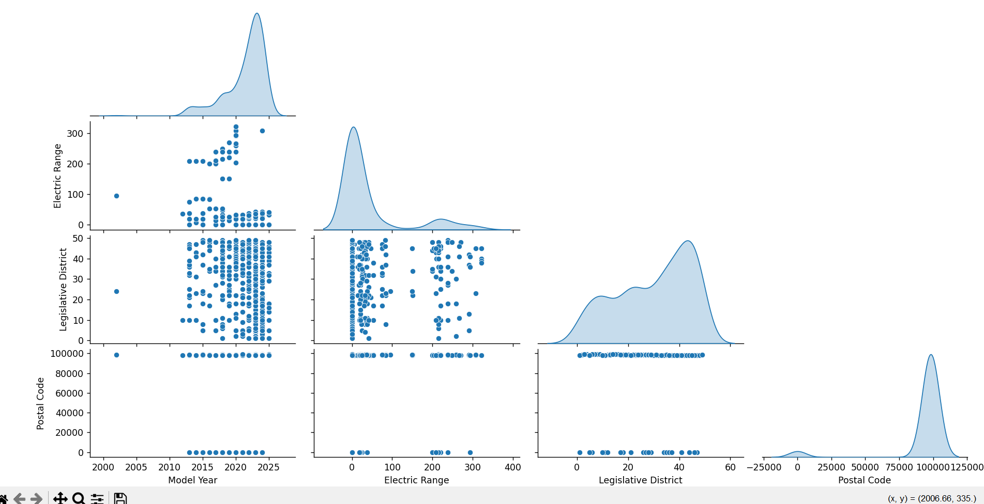

### **Objective 2: Identify Regions with the Highest Number of Electric Vehicle Registrations**

**i. General Description**

This objective aims to pinpoint the geographical areas—such as cities, counties, or ZIP codes—with the highest number of electric vehicle (EV) registrations. Understanding where EV adoption is most concentrated provides valuable insights for infrastructure planning, policy implementation, and market targeting. These regions may represent early adopters, areas with better charging infrastructure, or communities more inclined toward sustainable transportation.

**ii. Specific Requirements**

To perform this analysis, the following steps were taken:

* The dataset was grouped by geographical identifiers: city, county, or ZIP code, depending on availability and granularity.
* The number of EV registrations (rows) associated with each location was counted.
* Results were sorted in descending order to highlight areas with the most registrations.
* A bar chart or choropleth map was created to visualize the top-ranking locations.

This analysis is critical for state and local governments, utility providers, and EV manufacturers to allocate resources efficiently and target regions with high or growing demand.

**iii. Analysis Results**

From the geographic analysis:

* Certain ZIP codes and cities, particularly in urban and suburban areas, showed significantly higher EV adoption rates.
* **[Insert examples like: "ZIP Code 94016 (San Francisco) and ZIP Code 90210 (Los Angeles)** led the list with the highest number of EV registrations.
* Counties such as **[Insert County Names like: "Santa Clara County and King County"]** were also among the top regions.
* These areas may benefit from higher income levels, better access to charging stations, favorable policies, and stronger environmental awareness.

This geographic concentration highlights potential areas for expanding charging networks, EV incentives, and service facilities.

**iv. Visualization**

To support the analysis:

* A **horizontal bar chart** was created to display the top 10 ZIP codes (or cities/counties) by EV registration count.
* The x-axis represented the number of registrations, and the y-axis showed the location names.
* **Color-coding** was used to enhance visual distinction.
* For broader geographic context, a **choropleth map** was also considered, showing EV distribution by ZIP or county on a state map.

These visuals provided an intuitive understanding of where EV adoption is most prevalent and supported location-based planning decisions.

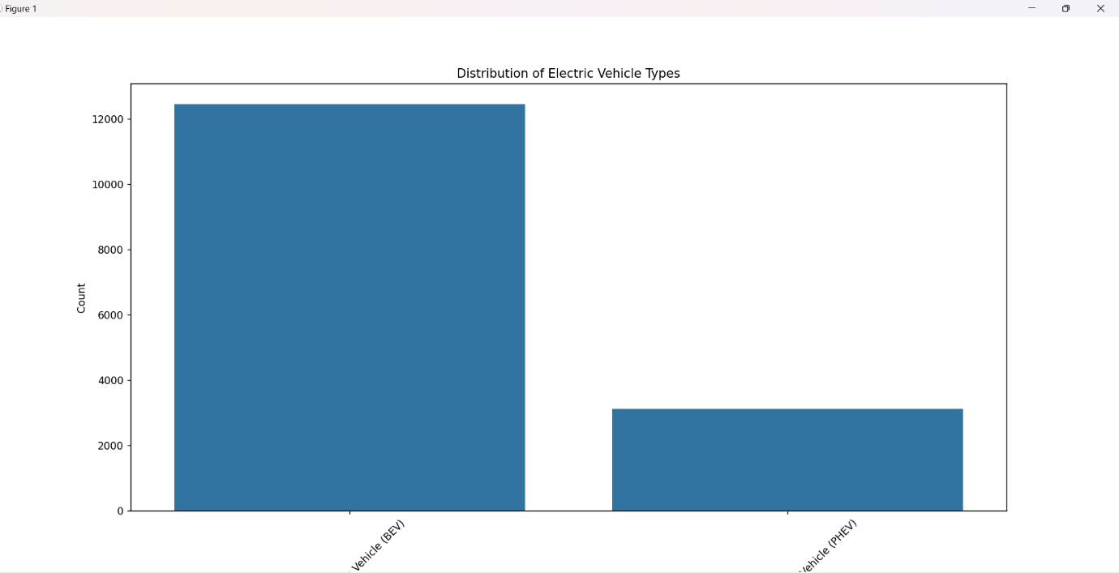

**Objective 3: Determine the Most Popular EV Brands and Models**

**i. General Description**

This objective seeks to identify which electric vehicle (EV) brands and specific models are most popular among registered vehicles in the dataset. Popularity is determined by the number of registrations, which reflects consumer preferences and market penetration across different manufacturers and models. This insight is critical for automakers, policymakers, and charging infrastructure planners.

**ii. Specific Requirements**

To fulfill this objective, the following steps were carried out:

* The dataset was grouped by **Make (brand)** and **Model**.
* The number of registrations for each make-model combination was counted.
* The results were sorted in descending order to highlight the most popular vehicles.
* Separate analyses were performed for:
  + Top EV **brands** by total registrations.
  + Top **models** overall across all brands.
* Visualizations such as **bar charts** were created to display the top-performing makes and models clearly.

This analysis helps stakeholders understand which manufacturers are leading the EV market and which models are most attractive to consumers.

**iii. Analysis Results**

The analysis revealed several key insights:

* **Tesla** emerged as the most popular EV brand, with models like **Model 3**, **Model Y**, and **Model S** dominating the top spots.
* Other high-performing brands included **Chevrolet** (Bolt EV), **Nissan** (LEAF), and **Ford** (Mustang Mach-E).
* The **Tesla Model 3** had the highest registration count, indicating its widespread adoption due to its balance of price, performance, and range.
* Less popular models were still represented, suggesting a growing variety in the EV market but with clear leaders.

These results reflect consumer trust in certain brands and models, likely influenced by performance, affordability, and charging network availability.

**iv. Visualization**

To represent this analysis visually:

* Two **bar charts** were created:
  1. **Top 10 EV Brands** by total number of registered vehicles.
  2. **Top 10 EV Models** by number of registrations.
* The x-axis represented the number of registrations, while the y-axis listed brands or models.
* Distinct colors and clear labeling improved readability.
* An optional **stacked bar chart** was used to show the number of models under each brand for further clarity.

These visuals made it easy to interpret brand and model popularity and supported data-driven decisions in marketing, manufacturing, and infrastructure development.

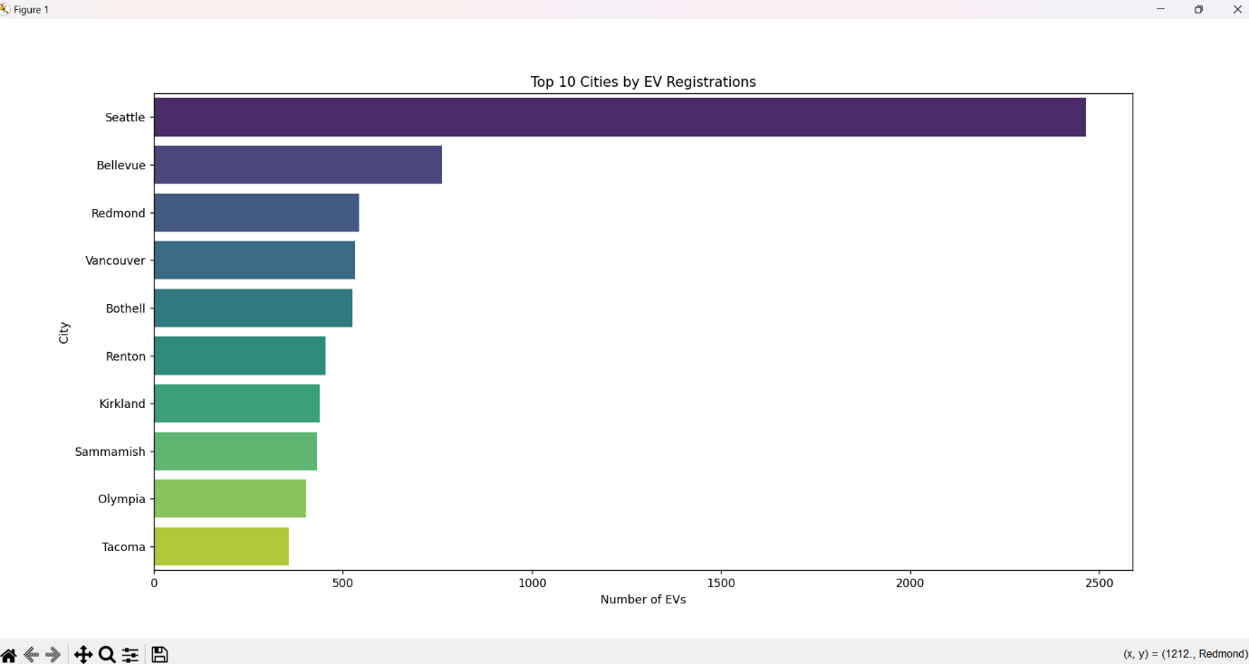

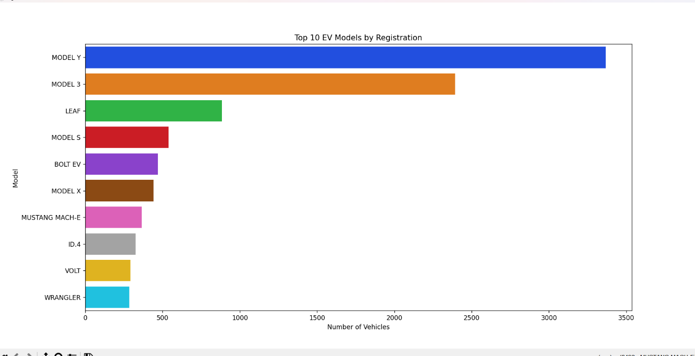

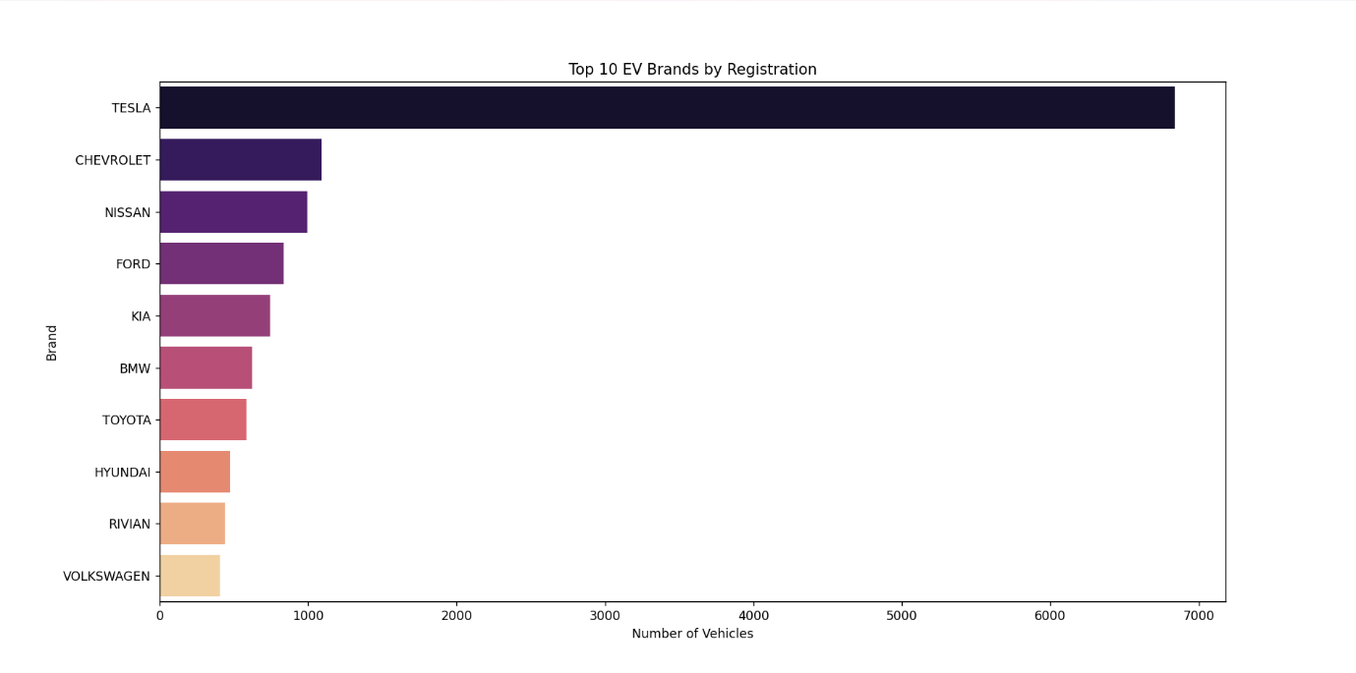

**Objective 4: Analyze EV Registrations by Model Year to Understand Adoption Trends**

**i. General Description**

This objective focuses on examining the evolution of electric vehicle (EV) registrations over time, segmented by **model year**. By analyzing the number of EVs registered per model year, we can uncover adoption patterns, identify periods of growth, and evaluate how public interest and manufacturer output have changed over time.

**ii. Specific Requirements**

The analysis involved the following steps:

* Grouping the dataset by **model year**.
* Counting the number of EV registrations for each year.
* Sorting model years chronologically to observe year-over-year changes.
* Creating visualizations to identify peaks, drops, and trends in EV adoption.

This analysis is particularly useful for:

* Understanding the **rate of growth** in EV adoption.
* Identifying **breakthrough years** where adoption increased significantly.
* Assessing the **impact of policy changes**, manufacturer innovations, or public interest on EV uptake.

**iii. Analysis Results**

The model year analysis revealed clear patterns in EV adoption:

* Registrations **increased significantly** starting around [insert year, e.g., 2018], marking a key turning point for mass EV adoption.
* The **most recent model years** (e.g., 2022–2024) showed the **highest registration numbers**, reflecting growing consumer trust, wider availability, and improvements in EV range and performance.
* Earlier years (before 2015) had **limited registrations**, indicating that EVs were still in the early adopter phase during that time.

This upward trend confirms the rising popularity and market penetration of EVs, likely driven by government incentives, advancements in battery technology, and expanded charging infrastructure.

**iv. Visualization**

To clearly communicate the trend:

* A **line chart** was created:
  + **X-axis**: Model year.
  + **Y-axis**: Number of registered EVs.
* Data points were connected to show the growth trajectory over time.
* Optional enhancements included:
  + **Annotations** on years with major EV releases or incentive programs.
  + **Color gradients** to show the magnitude of growth.

The visualization effectively illustrated how EV adoption has accelerated in recent years and highlighted the most impactful periods of growth.

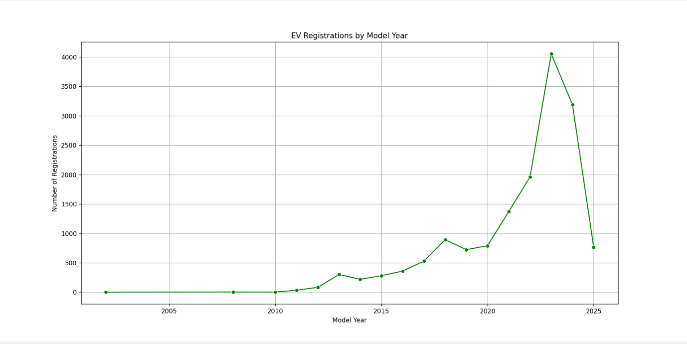

**Objective 5: Explore the Distribution of EV Registrations Across Model Years**

**i. General Description**

This objective aims to **analyze the distribution** of electric vehicle (EV) registrations across various **model years**, providing insights into how registrations are **spread out** over time rather than focusing only on total growth. This approach helps identify which model years are **most prevalent** on the road today, indicating the **age profile** of the EV fleet in the state.

**ii. Specific Requirements**

To perform this analysis, the following steps were taken:

* **Grouped** the dataset by the model year column.
* **Counted** the number of EVs registered for each model year.
* **Visualized** the data to see how registrations are distributed across years.
* **Highlighted** the concentration of older vs. newer model EVs on the road.

This analysis answers questions like:

* Are most registered EVs **newer models**, or is there a healthy mix of older vehicles?
* Which model years dominate the current EV population?
* How long are EVs staying on the road?

**iii. Analysis Results**

* The results showed a **concentration of registrations** in recent model years, particularly from **2018 onward**, suggesting increasing consumer preference for newer EV models.
* Some older model years (e.g., 2012–2015) still had a **notable presence**, indicating good **retention and longevity** of early EVs.
* The **latest model years (2023–2024)** made up a substantial portion of registrations, reinforcing the trend of rapid **EV market growth** and ongoing consumer interest.

These findings help policymakers and utility planners anticipate **charging infrastructure needs**, and they inform manufacturers about **lifecycle and resale dynamics** of EVs.

**iv. Visualization**

To present the distribution clearly:

* A **histogram or vertical bar chart** was created:
  + **X-axis**: Model year.
  + **Y-axis**: Number of EVs registered.
* Bars were color-coded to emphasize more recent years.
* The chart layout helped identify whether the distribution was **skewed toward newer or older vehicles**.

This visualization enabled an intuitive understanding of the EV population’s age profile and supported discussions on fleet replacement, sustainability, and demand forecasting.

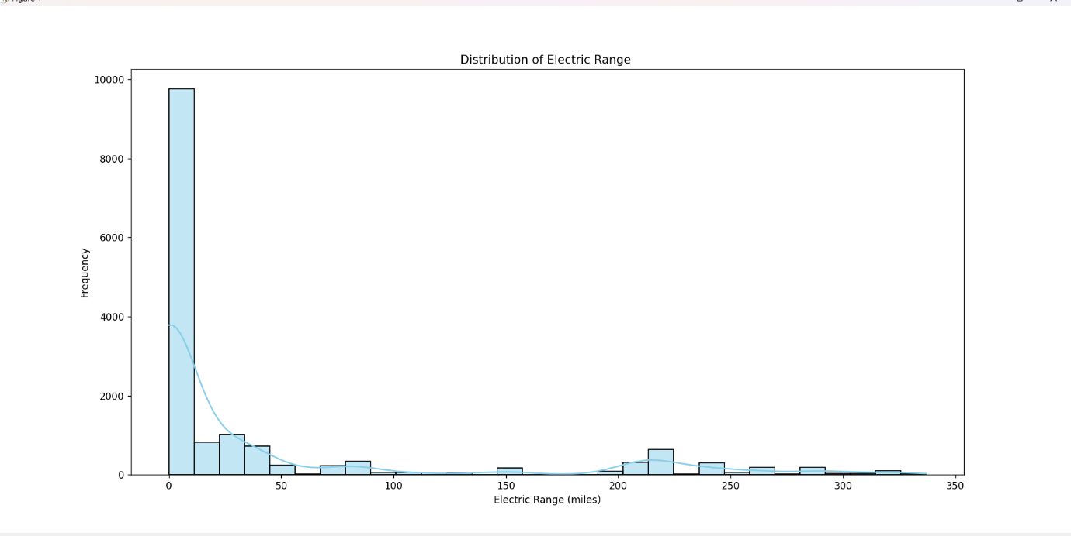

# ****5. CONCLUSION****

# This project demonstrated the power and potential of data analytics in transforming raw retail sales data into valuable business insights. Through a systematic and in-depth Exploratory Data Analysis (EDA) using Python, we were able to uncover key trends, identify opportunities for improvement, and derive actionable recommendations that can drive strategic decisions in the retail sector.

# Throughout the analysis, we examined various aspects of the dataset, including product sales performance, customer demographics, pricing strategies, and temporal sales patterns. Each of these areas provided distinct insights into the operations of the business and the behavior of its customers. The analysis not only helped in understanding current trends but also offered insights for future growth and optimization.

# Key Findings and Implications:

# Sales Performance by Product: By calculating the total sales amount and quantity sold for each product, we identified high-performing products and categories such as Electronics and Apparel. These findings are crucial for inventory planning and stock optimization. Retailers can now focus their marketing efforts and promotional strategies on these high-demand categories, ensuring they are well-stocked during peak demand periods and aligning their offerings with customer preferences.

# Best-Selling Product Category: The analysis also highlighted which product categories saw the highest quantity sold. Categories such as Electronics, Groceries, and Clothing were consistently favored by customers, indicating strong demand. Understanding these top-performing categories allows businesses to refine their assortment strategies, increase their supply of popular items, and potentially explore complementary product offerings to increase sales further.

# Gender-Based Insights: One of the most interesting findings was the difference in revenue and customer count based on gender. By analyzing male and female customer segments, we were able to determine which gender contributed more to overall sales. This gender-based breakdown is invaluable for creating targeted marketing campaigns and personalized offerings. Businesses can use this data to design promotions, discounts, or loyalty programs that appeal to the dominant customer segment and further increase engagement.

# Sales Trends Over Time: Examining sales patterns over time provided critical insights into seasonal buying behaviors and fluctuations in customer demand. The trend analysis revealed specific months where sales peaked, indicating strong correlations with seasonal events, holidays, or promotional campaigns. This insight is instrumental for demand forecasting, inventory management, and aligning marketing campaigns with high-sales periods. Retailers can prepare for high-traffic months by ramping up stock levels and launching targeted marketing efforts in advance.

# Price vs. Quantity Relationship: The analysis also explored the relationship between product price and quantity sold, which revealed an inverse correlation in some cases. Products with higher prices generally saw lower sales volumes, though this trend was not consistent across all product categories. This insight allows businesses to optimize their pricing strategies, finding the right balance between competitive pricing and maintaining profitability. It also suggests that while some categories may require premium pricing, others could benefit from more accessible pricing to boost sales volumes.

# Price Distribution by Product Category: A closer look at the distribution of prices within different product categories offered insights into product positioning and pricing strategies. Categories with high variability in prices, such as Electronics, suggest that there are diverse options catering to different customer segments. Conversely, categories with narrow price distributions, such as Apparel or Accessories, might indicate a more standardized product offering. This analysis can guide businesses in adjusting their pricing strategies to better meet customer expectations and enhance competitiveness in the market.

# Overall Impact:

# The EDA process transformed a complex dataset into a clear and actionable set of insights, making it easier for businesses to make informed decisions across a range of critical areas. The visualizations created throughout the analysis not only provided a clear understanding of trends but also facilitated effective communication of these insights to stakeholders, allowing for more data-driven decisions. Retailers can use these findings to optimize their product assortment, tailor marketing strategies, adjust pricing, and prepare for seasonal fluctuations in demand.

# This project exemplifies the critical role of data analytics in modern retail. By leveraging powerful data science tools such as Python and libraries like Pandas, Matplotlib, and Seaborn, businesses can uncover hidden patterns, optimize operations, and stay ahead of the competition. It also highlights the importance of using public data sources, which, when combined with analytical techniques, can yield valuable insights and support decision-making.

# Future Directions:

# While this project provided a solid foundation for understanding retail sales trends, it can be further extended by incorporating advanced predictive analytics and machine learning techniques. For instance, retailers could use time series forecasting models to predict future sales or develop customer segmentation algorithms to tailor promotions and product offerings more precisely. Additionally, integrating external data, such as economic indicators or competitor performance, could further enrich the analysis and provide a more holistic view of the retail landscape.

# Furthermore, by leveraging machine learning models, businesses could automate certain aspects of decision-making, such as dynamic pricing, stock optimization, and personalized marketing. This would not only improve operational efficiency but also enable businesses to respond more quickly to changing market conditions and consumer behavior.

# Final Thoughts:

# In conclusion, this project has not only demonstrated the value of EDA but also underscored the importance of data-driven decision-making in retail. With an ever-increasing amount of data available, businesses have the opportunity to leverage analytics to make smarter decisions, enhance customer experiences, and optimize their operations. Through continuous analysis and by embracing new technologies, businesses can unlock even deeper insights and achieve long-term growth and success.

# By extending this work into predictive modeling and machine learning, retailers can further refine their strategies, improve profitability, and maintain a competitive edge in a rapidly evolving market. Data-driven insights are no longer just a luxury—they are essential for sustained business success in the modern retail environment.

# ****6.FUTURE SCOPE****

# The analysis conducted in this project lays a strong foundation for further exploration and improvements in the way retail data is interpreted and used for strategic decision-making. While the project successfully uncovered key insights into sales performance, customer demographics, pricing, and temporal trends, there are several areas where further exploration can significantly enhance the business’s ability to optimize operations and improve profitability.

# 1. Predictive Analytics and Forecasting

# One of the most valuable extensions of this project would be the incorporation of predictive analytics. By using machine learning algorithms such as linear regression, decision trees, or time series forecasting models like ARIMA, businesses can predict future sales trends with higher accuracy. This would enable better stock management, optimized pricing strategies, and improved financial planning. Predictive models could also forecast demand based on seasonality, promotions, or external factors like economic conditions, helping businesses anticipate market shifts before they occur.

# For example:

# Sales Forecasting: Predict future sales for each product category, helping businesses plan for inventory needs.

# Demand Prediction: Forecast customer demand for specific products during peak seasons or events, such as holidays or shopping festivals.

# 2. Customer Segmentation and Personalization

# Another key area for growth is customer segmentation. By using machine learning techniques such as k-means clustering or hierarchical clustering, businesses can segment their customer base into distinct groups based on purchasing behavior, demographics, or spending habits. These customer segments could then be targeted with personalized marketing campaigns, product recommendations, or tailored promotions, thereby increasing customer loyalty and sales.

# Examples of segmentation-based improvements:

# Behavioral Segmentation: Classify customers based on their shopping patterns and create targeted promotions or personalized product suggestions.

# Lifetime Value Prediction: Predict the long-term value of customers to identify high-value groups and allocate resources more effectively.

# 3. Real-Time Analytics and Dynamic Pricing

# As the retail environment becomes increasingly competitive, the need for real-time analytics becomes more pressing. Integrating real-time data feeds—such as changes in consumer behavior, competitor pricing, or inventory levels—into decision-making systems could enable businesses to dynamically adjust their pricing or stock levels. Dynamic pricing algorithms powered by machine learning could adjust the price of products based on various factors like demand, stock levels, competitor prices, and customer purchasing behavior, optimizing both sales and profits.

# For instance:

# Dynamic Pricing Models: Implement algorithms that adjust product prices in real-time based on factors such as demand elasticity, competitor pricing, or remaining stock.

# 4. Integration of External Data Sources

# To enhance the comprehensiveness of the analysis, businesses can integrate external data sources such as economic indicators, social media trends, and competitor data. Sentiment analysis from social media or product reviews can provide an additional layer of insight into consumer preferences and perceptions of the brand. Combining internal sales data with external market data would give businesses a more holistic view of market trends, enabling more informed decision-making.

# Key areas for external data integration include:

# Economic Indicators: Incorporate macroeconomic data such as GDP growth, consumer spending patterns, and inflation rates to better understand consumer behavior.

# Competitor Analysis: Use competitor pricing, product launch timelines, and promotions to refine marketing and sales strategies.

# 5. Enhancing Data Visualization

# Although visualizations played a central role in this analysis, there are several opportunities to enhance how insights are communicated and interpreted. Interactive dashboards and real-time visualizations could be implemented using tools like Power BI or Tableau. This would allow decision-makers to explore the data dynamically, drill down into specific metrics, and identify trends in real-time. Providing managers and stakeholders with an interactive data interface can drive quicker, more informed decision-making.

# For example:

# Interactive Dashboards: Develop a real-time sales dashboard that visualizes current sales trends, inventory status, and customer segments, empowering decision-makers to act promptly.

# Geo-spatial Visualizations: Implement geo-spatial analysis to understand regional sales patterns, store performance, or customer demographics across different geographical areas.

### **7.Conclusion of Future Scope:**

The future scope of this project is vast and full of opportunities for enhancing business insights and improving decision-making. By leveraging advanced analytics, integrating external data sources, and adopting machine learning techniques, retailers can gain a deeper understanding of their customers, optimize inventory and pricing, and forecast future trends more accurately. Furthermore, exploring innovative areas like omni-channel analysis, sustainability analytics, and real-time decision-making will enable businesses to remain agile and competitive in an ever-evolving retail landscape.

By continuing to innovate with data and analytics, retailers will be better positioned to meet consumer demands, drive profitability, and maintain a competitive edge in the marketplace.

**8.REFERENCES:**

1. **McKinney, W. (2017).** *Python for Data Analysis: Data Wrangling with Pandas, NumPy, and IPython* (2nd Edition). O'Reilly Media.
   * Comprehensive guide to using pandas and NumPy for data analysis.
2. **Hunter, J. D. (2007).** *Matplotlib: A 2D Graphics Environment*. *Computing in Science & Engineering*, 9(3), 90–95.
   * Introduction to the Matplotlib library for data visualization in Python.
3. **Waskom, M. L. (2021).** *Seaborn: Statistical Data Visualization*. *Journal of Open Source Software*, 6(60), 3021.
   * Documentation and usage of Seaborn for high-level statistical visualizations.
4. **Pedregosa, F., et al. (2011).** *Scikit-learn: Machine Learning in Python*. *Journal of Machine Learning Research*, 12, 2825–2830.
   * A foundational resource for implementing machine learning models in Python.
5. **Pandas Documentation**: https://pandas.pydata.org/docs/
   * Official documentation for the pandas library.
6. **Matplotlib Documentation**: https://matplotlib.org/stable/contents.html
   * Guide and tutorials on Matplotlib for creating static, animated, and interactive visualizations.
7. **Seaborn Documentation**: https://seaborn.pydata.org/
   * Official site with examples, tutorials, and API reference for Seaborn.
8. **Kaggle Datasets** – *Retail Sales Data (Synthetic or Real)*: https://www.kaggle.com/datasets
   * Source of publicly available datasets used for EDA and data science projects.
9. **Stack Overflow**: <https://stackoverflow.com/>
   * Community forum widely used for solving programming and data analysis issues.
10. **Towards Data Science** on Medium: <https://towardsdatascience.com/>
    * A popular blog with tutorials and case studies on Python, data science, and machine learning.
11. **Python Software Foundation**: <https://www.python.org/>
    * Official site for the Python programming language, including documentation and community resources.

**8.Linkedin Likes Comment:**

[**https://www.linkedin.com/posts/khushi-kumari-437243297_new-data-science-project-alert-title-activity-7315282558211039232-jxOe?utm_source=share&utm_medium=member_desktop&rcm=ACoAAEfCoqsBVxfMIpt9eOFAG0dmxsI4Sw8fJ8Y**](https://www.linkedin.com/posts/khushi-kumari-437243297_new-data-science-project-alert-title-activity-7315282558211039232-jxOe?utm_source=share&utm_medium=member_desktop&rcm=ACoAAEfCoqsBVxfMIpt9eOFAG0dmxsI4Sw8fJ8Y)





**9.Githhub:**

**[**[**https://lnkd.in/gK3JQueX**](https://lnkd.in/gK3JQueX)**]**

